Exterminating Earthquake

~ AIM: The objective of my project is to check the disaster preparedness in the selected study area that is Rohit Kunj D.D.A market.

~ MEANING AND NEED OF DISASTER MANAGEMENT:

**Disaster management** can be **defined** as the organization and **management** of resources and responsibilities for dealing with all humanitarian aspects of emergencies, in particular preparedness, response and recovery in order to lessen the impact of **disasters**.

~ LOCATION OF STUDY AREA:

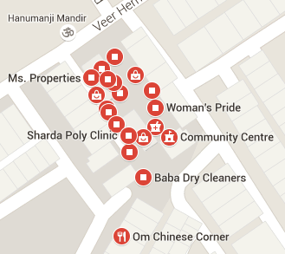

P.T.O

~ FLOW OF THE PROJECT:

* Understanding Disaster Management
* Disaster Preparedness plan
* Mapping the Study Area
* Evacuation Map
* Building a safe environment
* Awareness Generation

~ SAMPLE OF QUESTIONARE:

* In the case of an earthquake do I know all the exit doors?
* Do I understand what to do in an earthquake?
* What do you think is the level of the risk in an earthquake to your assets?
* Do you know the laws related to an earthquake?
* Are you aware about the safety measures for an earthquake?

~ REFERENCES

Wikipedia

Natgeo.com

Britannica.com

Google maps

Google images

BGS.com

SED.com